**OSH Authorities – Greece**

Source: <https://oshwiki.eu/wiki/OSH_system_at_national_level_-_Greece>

* OSH Infrastructure

Scheme:

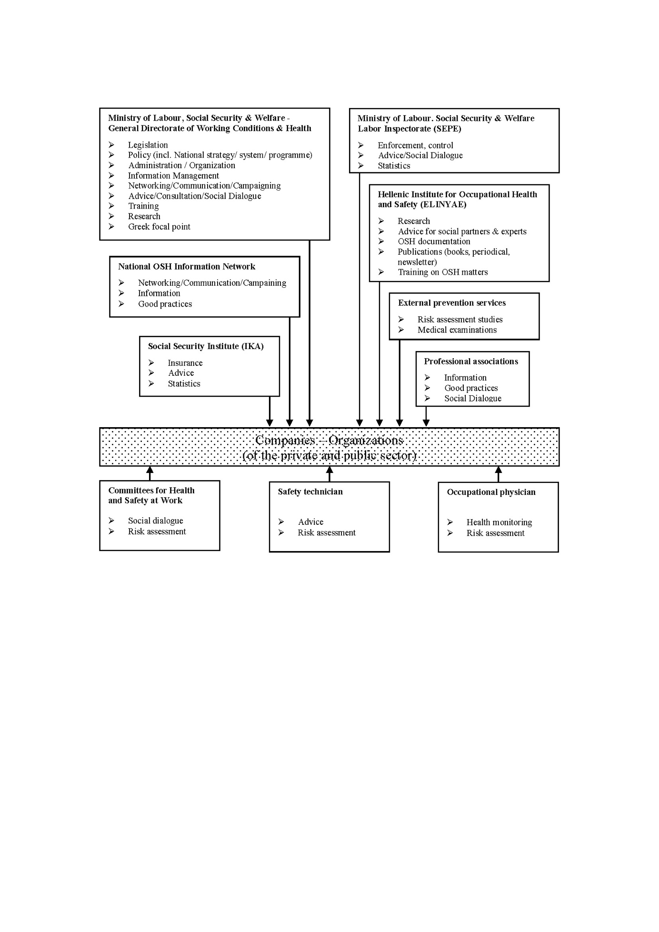

* OSH Authorities

|  |  |
| --- | --- |
| Name of Authority | The Directorate for Safety & Health at Work of the Ministry of Labour, Social Security & Social Solidarity |
| Link | <http://www.ypakp.gr> |
| Short abstract | The Directorate for Safety & Health at Work which promotes all issues related to occupational safety and health (except of the inspection and the enforcement of the national OSH legislation), is the principal OSH administration authority in the Ministry of Labour, Social Security & Social Solidarity. The Directorate is responsible among other duties for the planning, organization, implementation, monitoring and evaluation of the national OSH strategy and policies, the national OSH System as well as the National OSH Programme, in accordance to the national priorities and the running EU OSH strategy. Its activities are mainly directed in the fields of OSH legislation, policy making, decision making, administration, information management and documentation, awareness raising, networking, education, training and research.  To bring out these actions the aforementioned Directorate, with principle operational objective to plan, monitor and evaluate actions under the National Strategy for Safety and Health at Work, is divided into (6) six departments:   * Department of Working Conditions. * Department of Health Promotion, Harmful factors, Safety and Ergonomics. * Department of the National Focal Point for OSH Information and Documentation. * Department for the Major Accidents (under the Seveso Directive). * Department for OSH Training and Monitoring of Policies on OSH issues. * Department for People with Disabilities. |
| Link to OSH wiki | <https://oshwiki.eu/wiki/OSH_system_at_national_level_-_Greece> |

|  |  |
| --- | --- |
| Name of Authority | The Labour Inspectorate (SEPE) |
| Link | http://www.ypakp.gr/ |
| Short abstract | Law 2639/1998 [21] instituted the Labour Inspectorate (SEPE) [22] in its current form. Its Central Services are located in Athens and a number of Regional Services are located throughout the country. The Regional Services are divided into two categories: Sixteen (16) Regional Directorates for the Inspection of Social Matters such as illegal occupation, lack of social security cover etc. and five (5) Regional Directorates for the Inspection of Safety and Health at Work (former Centres for the Prevention of Occupational Risk-KEPEK) which involve inspection of work conditions for safety, health and hygiene matters. The Labour Inspectorate is responsible for the inspection and application of the national legislation either on social matters (work times, wages, social security, occupational legality) or on the physical conditions of work (safety and health) and plays also an important consulting role for properly informing and guiding the employers in order to achieve a better compliance level. Law 3996/2011 [23] has introduced reforms to the Inspectorate.  To fulfil its role, the inspectors for the safety and health at work can enter at any time in private or public workplaces without prior notice. It examines the implementation of OSH legislation. In case of violations it can impose administrative sanctions and fines. In case of major violations the inspectorate can order the temporary or permanent closure of a section or of the entire company. It investigates and reports on the causes of serious and fatal accidents. It investigates the causes of occupational diseases, takes samples and determines physical, chemical and biological parameters. Finally, it intervenes to resolve disputes in the workplace. |
| Link to OSH wiki | <https://oshwiki.eu/wiki/OSH_system_at_national_level_-_Greece> |

* Compensation and insurance bodies

|  |  |
| --- | --- |
| Name of the Body | The Social Insurance Institute (IKA) |
| Link | <http://www.ika.gr/en/home.cfm> |
| Short abstract | The Social Insurance Institute (IKA) is by far the largest social security organization in Greece. IKA covers salaried employees in Greece or abroad for an employer who is based in Greece, as well as those employees who offer full-time or part-time personal labour on commissioned work agreements and who are not insured with any other main insurance agency.  In Greece the old Royal Decree 473/1961 concerning "Contributions for Occupational Risk” is still in force. This Decree obliges nearly all employers to pay an insurance contribution to IKA amounting to 1% of the total wages. Theoretically this contribution is paid for protection against occupational risks. However, in reality the sum is not used for this purpose and is redirected to further finance IKA’s obligations (pensions etc). Given that occupational diseases are significantly underreported, this leads to reduced insurance coverage. A continuous demand by the Trade Unions is the establishment of a Body of Insurance against Occupational Risks under IKA’s umbrella. |
| Link to OSH wiki | <https://oshwiki.eu/wiki/OSH_system_at_national_level_-_Greece> |

|  |  |
| --- | --- |
| Name of the Body | The single State Social Security Organization (EFKA) |
| Link | <http://www.efka.gov.gr/> |
| Short abstract | Since the 1st of January 2017 a single State Social Security Organization named EFKA has been put in operation as the result of the unification of the pre-existing social security institutions operating in Greece. Regulated by the law n.4387 (FEK 85/A’/12-5-2016) and with a view to ensuring a decent living and social protection, in terms of equality, social justice, redistribution and solidarity of generations, all state social benefits are granted within the framework of the umbrella organization EFKA which includes the National Health System for health benefits, the National Social Solidarity System for the welfare benefits and the National Social Security Funds for the insurance benefits. Everyone is now insured with EFKA, employers and employees either as wage earners or self-employed pay their contributions to EFKA and all pensioners receive their main pension from the same organization. |
| Link to OSH wiki | <https://oshwiki.eu/wiki/OSH_system_at_national_level_-_Greece> |

* Research Institutes

|  |  |
| --- | --- |
| Name of the Institute | The Hellenic Institute for Occupational Health and Safety (ELINYAE) |
| Link | <http://www.elinyae.gr/el/index.jsp> |
| Short abstract | The Hellenic Institute for Occupational Health and Safety (ELINYAE) is a bipartite (employers – employees) non-profit organization. The General Confederation of Greek Workers (GSEE), the Federation of Greek Industries (SEV), the National Confederation of Hellenic Commerce (ESEE), the Confederation of Small and Medium-sized Enterprises (GSEVEE) founded the Institute in 1992. Amongst others, its objective is to study the impact of applications of new technologies and of new preventative measures for occupational risks and to provide expertise on issues of occupational health and safety. |
| Link to OSH wiki | <https://oshwiki.eu/wiki/OSH_system_at_national_level_-_Greece> |

* Other OSH Services

|  |  |
| --- | --- |
| Name of Association | The Greek Society for Environmental and Occupational Medicine (EEIEP) |
| Link | <http://www.iatrikiergasias.gr/> |
| Short abstract | The Greek Society for Environmental and Occupational Medicine is a professional and scientific association providing services to their members on OSH matters. They help them fulfil their duties as occupational physicians, members of Committees for Health and Safety at Work (EYAE), unionists, researchers etc. They also participate via their representatives in the national OSH tripartite social dialogue which is taking place at the national Council for the Safety and Health of Workers (S.Y.A.E.). |
| Link to OSH wiki | <https://oshwiki.eu/wiki/OSH_system_at_national_level_-_Greece> |

|  |  |
| --- | --- |
| Name of Association | The Permanent Committee on Occupational Safety and Health of the Technical Chamber of Greece (TEE) |
| Link | <http://portal.tee.gr/portal/page/portal/TEE_HOME> |
| Short abstract | The Technical Chamber of Greece was established in 1923, is a legal entity of public law with elected administration. According to the rules of the Hellenic State as a legal entity of public law, it is formally supervised by the Ministry of Infrastructure for Transport and Networks (MINISTRY SUBMEDI).  The Technical Chamber of Greece aims to promote science in the fields related to the specialty of its members, technology and technology in general and their exploitation for the economic, social and cultural development of the country in the framework of the principles of sustainability and protection of the environment. |
| Link to OSH wiki | <https://oshwiki.eu/wiki/OSH_system_at_national_level_-_Greece> |

|  |  |
| --- | --- |
| Name of Association | The Department for the Environment and Health and Safety at Work of the Greek Chemists’ Association (EEX) |
| Link | <http://www.eex.gr/> |
| Short abstract | The Department for the Environment and Health and Safety at Work of the Greek Chemists’ Association (EEX). Is a scientific associations providing services to their members on OSH matters. |
| Link to OSH wiki | <https://oshwiki.eu/wiki/OSH_system_at_national_level_-_Greece> |

* Standardization bodies

|  |  |
| --- | --- |
| Name of the Body | The Hellenic Organization for Standardization (ELOT) |
| Link | <http://www.elot.gr/default_en.aspx> |
| Short abstract | The Hellenic Organization for Standardization (ELOT) is the national body responsible for the elaboration, approval, publication and distribution of Hellenic Standards. The elaboration of Standards is entrusted to ELOT’s Technical Committees and Working Groups. Representatives from both the public and the private sector express their opinions on the different issues in order to achieve maximum possible consensus among them. The Technical Committee 59 (Health and Safety at Work) is responsible for the elaboration of standards on OSH issues. The Ministry of Labour, the Ministry of Development, the Technical Chamber of Greece (TEE), the Greek Chemists Association (EEX), the Greek Society for Environmental and Occupational Medicine (EEIEP), the General Confederation of Greek Workers (GSEE), the Federation of Greek Industries (SEV) as well as representatives from the private sector provide their expert opinion to this Technical Committee. |
| Link to OSH wiki | <https://oshwiki.eu/wiki/OSH_system_at_national_level_-_Greece> |